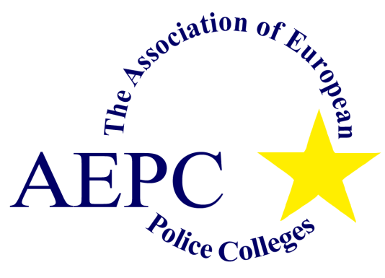
Programme for the Actions Workshop
“Domestic Violence”
Dnipropetrovsk, 28-30 September 2021

The main goal of this workshop is to share as much experience as possible through practical examples in order to raise understanding of the complexity of domestic violence and to highlight the necessity of inter-institutional cooperation!

Tuesday, 28th September
09.00 Official Opening by Mario Krebs, AEPC Secretariat.
Welcome address by the Rector of Dnipropetrovsk State University, Colonel Andrii Fomenko,
Afterwards family picture

09.45 Introduction to the workshop: Aim, Agenda, Expectations
Afterwards introduction round (who is in the room?)

11.00 Coffee break

11.15 Theoretical input (Part I)
- Understanding of the root causes of Domestic Violence
- Blow-fish model
- How the human brain works
- Influence of communication
13.00 Lunch break
14.00 Theoretical input (Part II)
15.30 Coffee break
15.45 Case study in groups
16.30 Sum up the day
17.00 End of day one

Wednesday, 29th September
09.00 Reflection on the previous day
09.15 Backpack model and introduction to a case study
10.45 Coffee will be served during the case study
11.30 Presentation of the outcomes of the case study
12.00 The role of Men and Women / Equality – Stability
13.00 Lunch break
14.00 SARA
- Meaning
- Criteria
- Case study
15.30 Coffee break
15.45 Theoretical input
- Discussion: Education vs. Violence
16.30 Sum up the day
17.00 End of day two

Thursday, 30th September
09.00 Reflection on the previous day
09.15 Theoretical input
- Witnessing violence / co-dependency
- Victims / vulnerable groups
10.30 Coffee break
13.00 Lunch break
14.00 Sum up the last three days (by the trainer team)
15.00 Evaluation of the three days (by the participants)
15.45 Certificates and official closing of the workshop by AEPC Secretary General, Colonel Peter Lamplot

